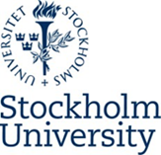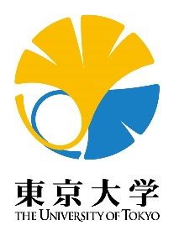

Preliminary program for student workshop
“Education models in the world and education transfer –
The example of Education for Sustainable Development (ESD)”

Planning and coordination: Assoc. Prof. Susanne Kreitz-Sandberg

The University of Tokyo
Faculty of Education Bldg., Conference room 1

Thursday, December 13
9:30 | Room opens
10:00-10:10 | Welcome to day 3 of the study exchange  Kanako N. Kusanagi and Fumiko Takahashi
10:10-10:25 | Education models in the world and education transfer  Susanne Kreitz-Sandberg
10:25-10:50 | Working with ESD at a Swedish senior high school. Examples from teaching and international collaboration  Peter Hammers, Magnus Nyström and Bennie Zetterström
10:50-11:00 | The role of of altruism for ESD - from cognitive/brain science and behavioral economics points of view  Kenji Morita
11:00-11.10 | Explanation of group work task and group division by topics  Susanne Kreitz-Sandberg and Kenji Morita
11:15-14:30 | Group work including lunch in working groups  (4-6 students per group; see comments below).
14:30-15:45 | Students meet again in whole group and report on their work.  Chairs: Kenji Morita and Susanne Kreitz-Sandberg
15:45-16:00 | Round up of the day.
For the description of the group work, please refere to next page.

Working tasks for the students/group
In advance
Please search information about a project, preferably in your own country that works with ESD. Each student will get about 10 minutes during the group work to describe this project. “Project” can mean any kind of educational initiative, from preschools or schools to higher education, NGO:s or governmental initiatives. You can choose a project that you are familiar with or a project about which you found information in the literature or on the internet.

Take the following questions into account:
- Describe the project. Why did you choose just this project?
- In which way does the project work with ESD?
- What is the strength of this project?
- Do you see any specific problems in relation to the project (practical, theoretical)?
- Which possibilities do you see to learn from this project (educational transfer)?

During the day (ca. 11:00-14:30)
- Introduce yourself to the group.
- Tell each other about the project you chose according to the above posed questions.
- Discuss the projects.
- Prepare a short presentation about the results of your discussion for the other groups. Do not repeat an individual description of the single projects but try to summarize your learning outcome from the discussion on the questions regarding possibilities or difficulties for educational transfer.

Group composition
There will be four groups with 4-6 students:
- Group 1. Quality Education – Ensure inclusive and equitable quality education and promote lifelong learning opportunities for all (SDG 4)
- Group 2. Gender Equality – Achieve gender equality and empower all women and girls (SDG 5)
- Group 3. Climate Action – Take urgent action to combat climate change and its impacts (SDG 13)
- Group 4: Zero Hunger – End hunger, achieve food security and improved nutrition and promote sustainable agriculture (SDG 2)

